**Block diagram**

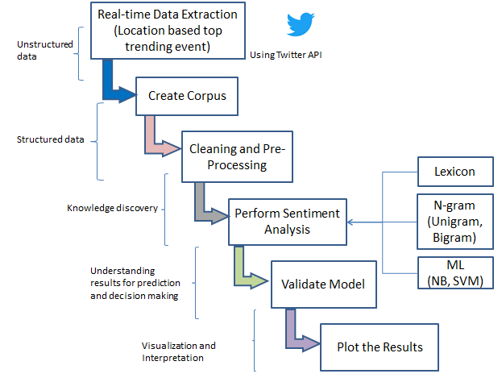

In this block diagram, the first step is to use the Twitter API to collect tweets related to the top colleges. The collected data is then cleaned to remove unwanted elements such as URLs, special characters, and stop words. The next step is to preprocess the data, which involves tokenization, stemming, and feature extraction.

The preprocessed data is then fed into a sentiment analysis algorithm to determine the sentiment of each tweet. This can be done using a rule-based approach, a machine learning approach, or a combination of both.

Finally, the results are visualized using graphs or charts to provide insights into the overall sentiment towards the top colleges on Twitter. This could include the number of positive, negative, and neutral tweets, as well as word clouds to show the most common words associated with each sentiment.